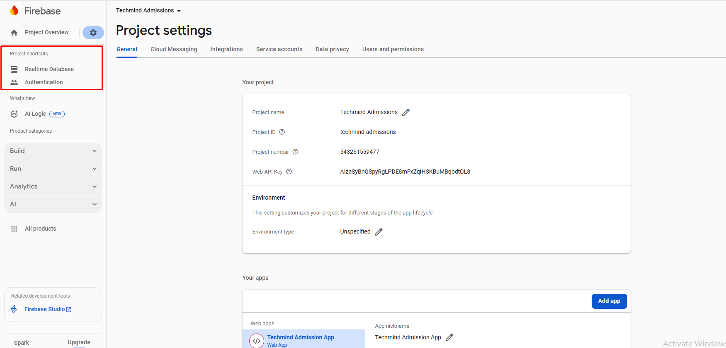

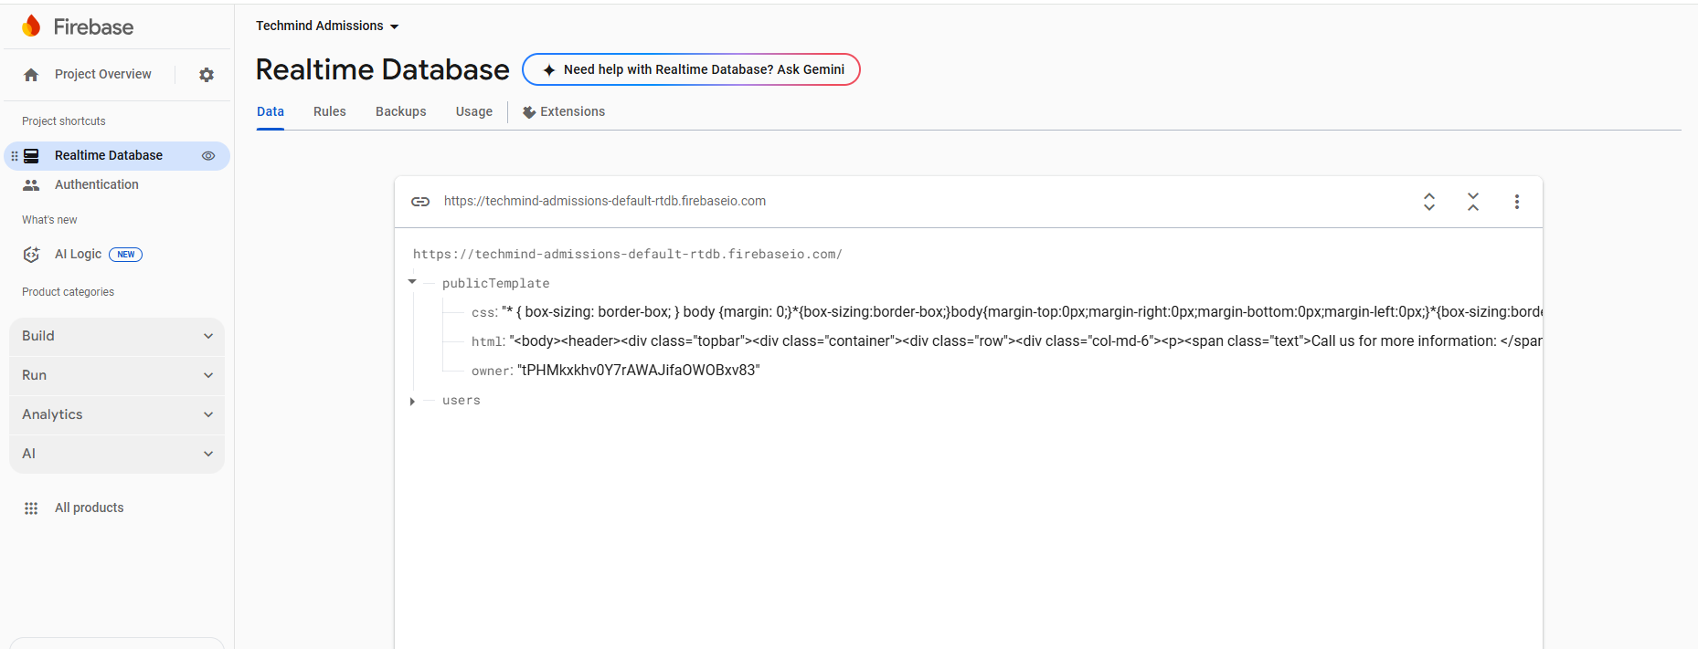

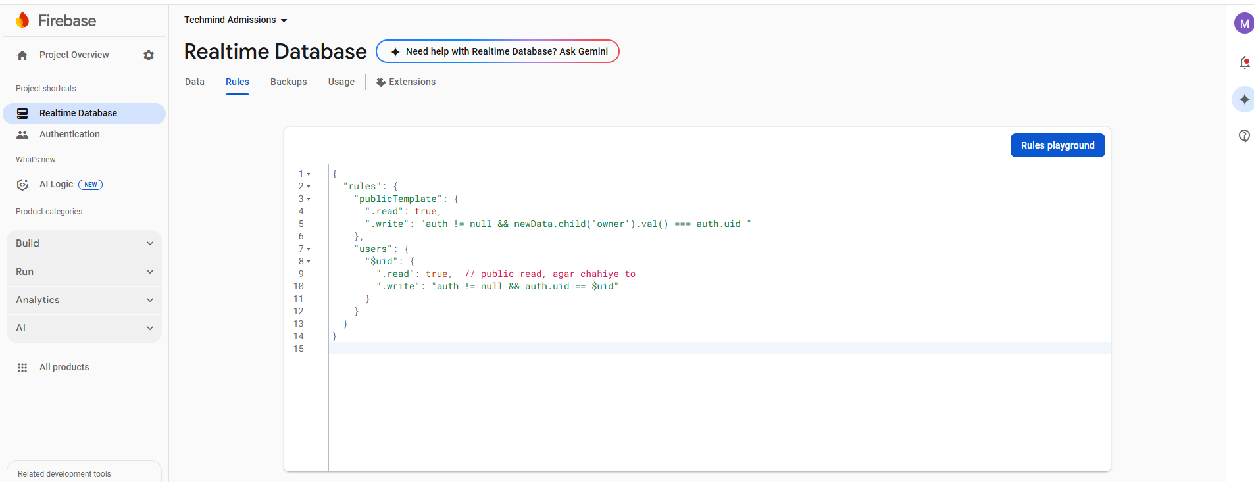

**Rules**

{

"rules": {

"publicTemplate": {

".read": true,

".write": "auth != null && newData.child('owner').val() === auth.uid "

},

"users": {

"$uid": {

".read": true, // public read, agar chahiye to

".write": "auth != null && auth.uid == $uid"

}

}

}

}

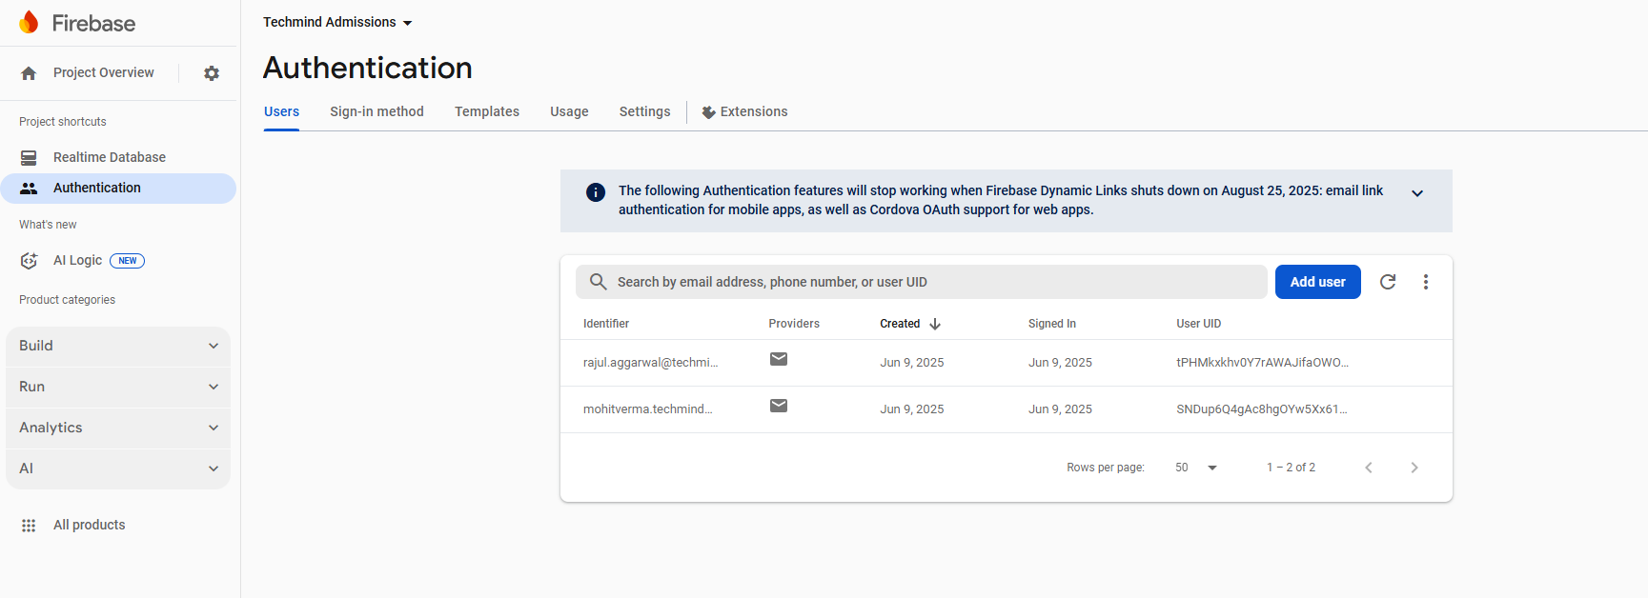

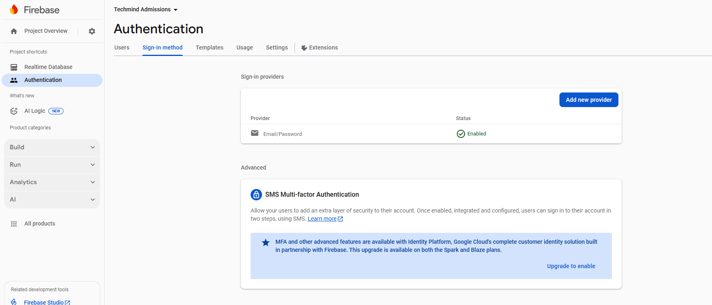

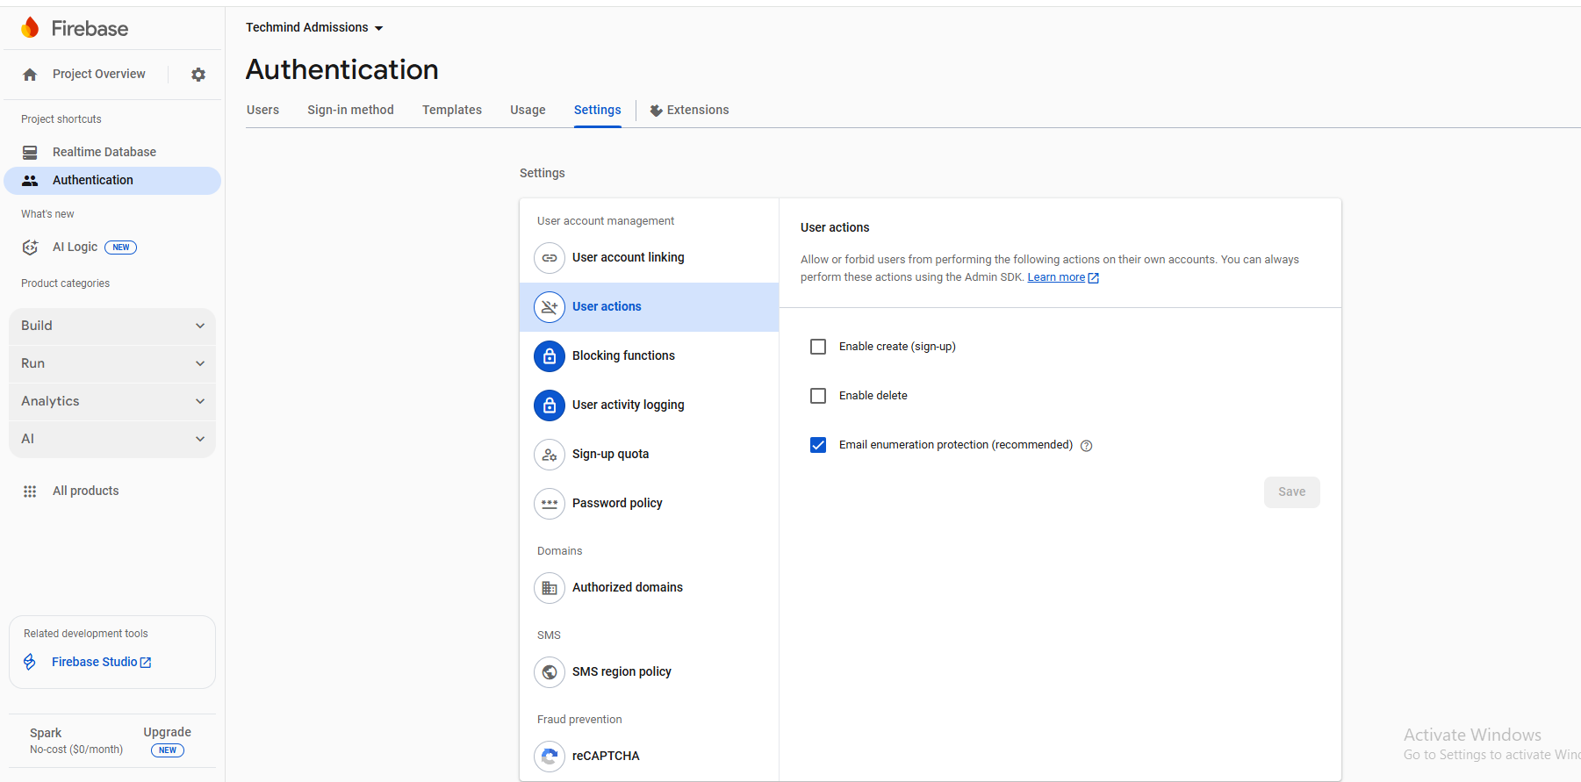

{

"rules": {

"publicTemplate": {

".read": true,

".write": "auth != null && newData.child('owner').val() === auth.uid "

},

"users": {

"$uid": {

".read": true, // public read, agar chahiye to

".write": "auth != null && auth.uid == $uid"

}

}

}

}